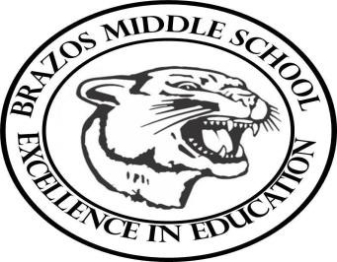

|  |  |  |
| --- | --- | --- |
| Week 22 | | 6th Grade World Geography |
| Monday: 2/3/25 | Thursday: 2/6/25 | |
| Texas World Studies:  TEKS: 1A,2B,3A, 3C, 3D, 5A, 6A, 7A,8B, 9A, 9C, 10B,  13A, 15A,  16A,17A, 18B,  Objective: Discuss East / Southeast Asia China’s Continue with Branches of Govt., Governmental Abuses by China on other Asian Countries.      TSW:  Students write down Motivational Quote copy vocabulary  Students will discuss and take notes on East and  Southeast Asia. China’s Branches of Govt., Governmental Abuses by China on other Asian Countries. | Texas World Studies:  TEKS: 1A,2B,3A, 3C, 3D, 5A, 6A, 7A, 8B, 9A,9C,10A,10B,13A,  15A,16A, 17A, 18B,2B, 3C, 4B, 7A, 8A, 9A, 10B, 13D,16A, 17B      Objective:  CBA TEST Day    TSW:  Review CBA Test  Take CBA Test | |
| Tuesday: 2/4/25 | Friday 2/7/25 | |
| Texas World Studies:  TEKS: 2B, 3C, 4B, 7A, 8A, 9A, 10B, 13D,16A, 17B,  Objective:  Discuss South Asia Geography / History / Politics of  India,.Nepal, Pakistan, Bangladesh, Sri Lanka  Assign Map of South Asia    TSW:  Students write down Motivational Quote copy vocabulary  Students will complete Map of South Asia 3C, 4B  Students will discuss and take notes on South Asia  Geography / History / Politics of India,.Nepal, Pakistan, Bangladesh, Sri Lanka | Texas World Studies –.  TEKS: TEKS: 1A,2B,3A, 3C, 3D, 5A, 6A, 7A, 8B,  9A,9C,10A,10B,13A, 15A,16A, 17A, 18B,2B, 3C, 4B, 7A, 8A, 9A,  10B, 13D,16A, 17B    Objective:  Students will Take CBA Test  Movie on India: Mohandas K. Gandhi  TSW…  Students will Take CBA Quiz  Movie on Mohandas K. Gandhi | |
| Wednesday: 2/5/25 |  | |
| Texas World Studies:  TEKS: 1A,2B,3A, 3C, 3D, 5A, 6A, 7A, 8B,  9A,9C,10A,10B,13A, 15A,16A, 17A, 18B,2B, 3C, 4B, 7A,  8A, 9A, 10B, 13D,16A, 17B    Objective:    CBA GIMKIT REVIEW Game    TSW:  Students write down Motivational Quote copy vocabulary |  | |

|  |  |
| --- | --- |
| Students will play CBA GIMKIT REVIEW |  |

Teacher: Rodney Dowell