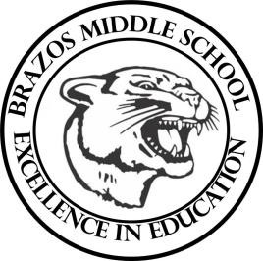

Teacher Chris Stanley 2023 Social Studies 6th grade
Week 3- 1st- 6 weeks | Aug. 28- Sept. 1

Monday |  | Thursday
TEKS:  Objective:Students will learn that . . .  - Earth’s movement affects the amount of energy we receive from the sun.  - Earth’s seasons are caused by the planet’s tilt. Student Work : Start Vocab |  | TEKS: (7.1B, 7.2B)  Objective: Students will begin group project The Earth’s Water Cycle.  Student Work: Students will create the Water Cycle project in Google slides.
Tuesday |  | Friday
Teks (6B 7B 7C)  Objective: Students will learn that . . . 1. Salt water and freshwater make up Earth’s water supply. 2. In the water cycle, water circulates from Earth’s surface to the atmosphere and back again. 3. Water plays an important role in people’s lives  Student Work: Sec 2 Vocab Quiz sec 1 |  | TEKS:)  Objective: Students will complete the Water Cycle project and begin Chapter 2 review.  Student Work: Complete water cycle project
Wednesday
TEKS ( 6A)
Objectives:Students will learn that . . .
- Earth’s surface is covered by many different landforms.
- Forces below Earth’s surface build up our landforms.
- Forces on the planet’s surface shape Earth’s landforms.
- Landforms influence people’s lives and culture. Students Work – Vocab

