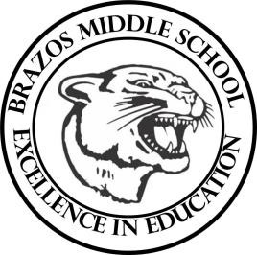

Teacher_Chris Stanley Social Studies 6th grade
Week 5- 1st- 6 weeks | Sept. 11th-15th

Monday |  | Thursday
TEKS: 6A-6B  Objective: Students will learn how geographers use temperature and precipitation and native plant life to identify climate zones.  Student Work: Start Vocab |  | TEKS  Objective- Students will create study guide for  CBA – Test review  Student Work: CBA study guide
Tuesday |  | Friday
TEKS: (6A-6B)  Objective: Students will continue discussion over sec.#3 over the environment and begin sec. 4 over Natural resources. Student Work: |  | TEKS (2A 3A 6A 6B) Objevtive: CBA Exam Student Work:
Wednesday
TEKS (6A-6B)

Objective: Students will recall information over chapter 3 Students will complete chapter review activity

Student Work- Chapter review activity
Create study guide for CBA exam

