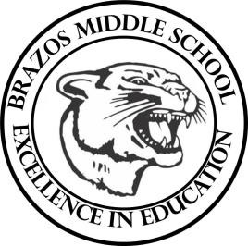

Teacher_Chris Stanley 6th grade Social Studies 2023
Week 33 – 6th 6 Weeks | April 22nd – April 26th

Monday |  | Thursday
TLW: The students will review over Sec.4  The students will complete the review which will help them for their Chapter Exam the next day  TEKS: 6A, 6B, 6C, 6D |  | TLW: The students review over Chapter 29 exam  The students will begin Chapter 30, Pacific Realm  TEKS: 6A, 6B
Tuesday |  | Friday
TLW: The students will complete their Chapter 29 test |  | TLW: The students will review over sec. 1 using an activity set up by the instructor  TEKS: 6B
Wednesday
STAAR testing

