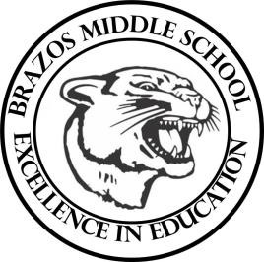

Teacher_Chris Stanley 6th grade Social Studies 2023
Week 30 – 5th 6 Weeks | April 1st– 5th

Monday |  | Thursday
Holiday  Work Day |  | TLW: CBA Day
Tuesday |  | Friday
TLW: CBA Corrections  TEKS: 6.1A , 6.3C , 6.3D, 6.6A , 6.10B , 6.14B , 6.17A , 6.19A |  | TLW: The students will review over the previous days activity to gain a better understanding.  TEKS: 6.1A, 6.3C
Wednesday
TLW: The students will complete a China, Mongolia and Taiwan Sec. 3 Scavenger hunt

TEKS: 6.1A , 6.3C , 6.3D, 6.6A , 6.10B , 6.14B , 6.17A , 6.19A, 6.20B, 6.21A

