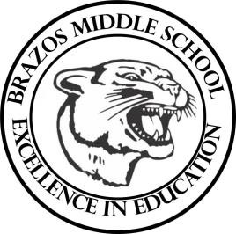

Teacher_Chris Stanley 6th grade Social Studies 2023
Week 29 – 5th 6 Weeks | March 25th– 29th

Monday |  | Thursday
TLW: The students will finish learning about the history of China  History of China Sec. 2 W/S  CBA Review  TEKS: 6.20D |  | TLW: CBA Day
Tuesday |  | Friday
TLW: The students will review over the History of China  History of China Pop Quiz  CBA Review  China, Mongolia and Taiwan Sec. 2 Scavenger Hunt  TEKS: 6.1A , 6.3C , 6.3D, 6.6A , 6.10B , 6.14B , 6.17A , 6.19A |  | Good Friday
Wednesday
TLW: The students will review for our CBA

China, Mongolia and Taiwan Sec. 3 Given

TEKS: 6.1A , 6.3C , 6.3D, 6.6A , 6.10B , 6.14B , 6.17A , 6.19A, 6.20B, 6.21A

