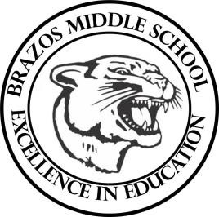

Teacher_Chris Stanley 6th grade Social Studies 2023
Week 23 – 4th 6 Weeks | February 5th – 9th

Monday |  | Thursday
TLW: The students will begin learning about the oil crisis and conflict over oil in the middle East  CBA 4 review  Southwest Asia Sec. 1-4 Assigned |  | CBA 4
Tuesday |  | Friday
TLW: Southwest Asia Sec. 1-4 W/U  The learner will continue to learn about the oil crisis  CBA 4 Review  1a, 1b, 2a, 2b, 3a, 3b, 3c, 3d,4b, 4c, 15b, 18b, 21b, 21c, 22d |  | TLW: CBA 4 Corrections  Southwest Asia Sec. 1-4 W/U due
Wednesday
TLW: Southwest Asia Sec. 1-4 W/U
The learner will continue to learn about Oil crisis and conflict in North Africa
CBA 4 Review
1a, 1b, 2a, 2b, 15a, 15b, 15f, 17d, 17e, 19a, 21b, 21c, 21d, 22d

Southwest Asia/North Africa Map due

