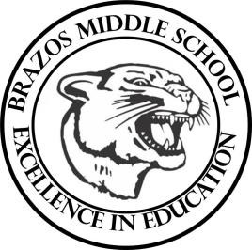

Teacher_Chris Stanley 6th grade Social Studies 2023
Week 20 – 4th 6 Weeks | January 15th – January 19th

Monday |  | Thursday
MLK Day |  | Student Work: Russia and Eurasian Vocab Quiz  TEKS: 6.1A, 6.1B, 6.19A  TLW: The learner will learn how Russia has changed into modern day  Russia and Eurasian Vocab Quiz
Tuesday |  | Friday
Bad Weather Day (School Cancelled) |  | Student Work: Russia and Eurasian Unit Quiz
Wednesday
Student Work: Eurasian Vocab Review
TEKS: 6.1A, 6.1B, 6.19A
TLW: The learner will further learn about Russian history
Russia Sec. 3 HW given

