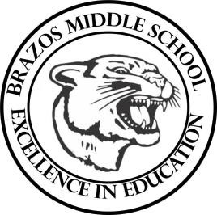

Teacher_Chris Stanley 6th grade Social Studies 2023
Week 19 – 4th 6 Weeks | January 8th– January 12th

Monday |  | Thursday
Student Work: Russia and Eurasian Vocab  TEKS: 6.3C, 6.3D  TLW: The learner will begin to learn about the global location and geography of Russia as well as the location of major rivers and seas.  Russia Sec. 1 H/W Given |  | Student Work: Russia and Eurasian Vocab Cont.  TEKS: 6.1A, 6.1B, 6.19A  TLW: The learner will begin to learn about Russian History including Czars  Russia Sec. 2 H/W Given
Tuesday |  | Friday
Student Work: Russia and Eurasian Vocab Cont.  TEKS: 6.6A, 6.6C, 6.17A  TLW: The Learner will analyze the impact natural resources have on individual country’s economy including trade and methods of trade.  The learner will begin learning about the culture and Religion of Eastern Europe and Russia |  | Student Work: Russia and Eurasian Vocab Cont.  TEKS: 6.1A, 6.1B, 6.19A  TLW: The learner will further learn about the History of Russia  Russia Sec. 2 H/W Due
Wednesday
Student Work: Cont. Eurasian Vocab Review
TEKS: 6.1B, 6.3C, 6.3D
TLW: Students will begin to label countries and bodies of water in Russia Map
Russia Sec. 1 HW due

