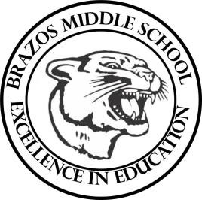

Teacher_Chris Stanley 6th Grade Social Studies 2023
Week 11- 2nd 6 weeks | October 23rd-27th

Monday |  | Thursday
Student Work: CBA Review  Begin Chapter 10 Vocab  TEKS: 6A, 6B  TLW: The learner will complete a Chapter 10 Assessment for a grade  The student will be able to identify the physical geography of South America |  | Student Work: CBA #2 EXAM
Tuesday |  | Friday
Student Work:  TEKS: 1A, 1B, 2B, 4A  TLW: The student will begin learning about the history of Colombia in South America. |  | Student Work: TEST CORRECTIONS
Wednesday
Student Work: CBA Review
TEKS: 1A, 1B, 2B, 3D
TLW: The student will learn about the modern culture and geography in South America

