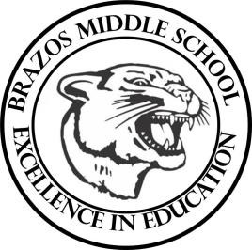

Teacher_Chris Stanley 6th Grade Social Studies 2023
Week 10- 2nd 6 weeks | October 16th – 20th

Monday |  | Thursday
Student Work: Students will begin Chapter 9 Vocab  TEKS: 6A, 6B  TLW: The student will be able to identify the physical geography of Central America and the Caribbean. |  | Student Work: Chapter 9 Assessment  CBA Review  Begin Chapter 10 Vocab  TEKS: 6A, 6B  TLW: The learner will complete a Chapter 10 Assessment for a grade  The learner will begin a review packet for their CBA on the 26  The student will be able to identify the physical geography of South America
Tuesday |  | Friday
Student Work:  TEKS: 1A, 1B, 2B  TLW: The student will learn of the history of Central America and the Caribbean and the influence of Spain. |  | Student Work:  TEKS: 1A, 1B, 2B, 4A  TLW: The student will begin learning about the history of Colombia in South America.
Wednesday
Student Work: Chapter 9 Vocab Quiz
TEKS: 1A, 1B, 2B, 3D
TLW: The student will learn further information about the history of the Caribbean Islands

