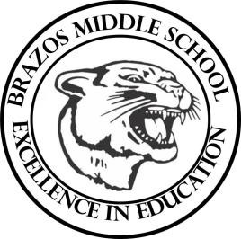

Teacher_Chris Stanley 6th Grade Social Studies 2023
Week 7- 2nd 6 weeks | September 25th – 29th

Monday |  | Thursday
Student Work: Chapter 6 Test On GC  Begin Chapter 7 Vocab  TEKS: 3A, 3B, 3C, 4D,5A, 5B  TLW:  Learn about the geographic make-up of Canada and the location of natural resources. |  | Student Work: Chapter 7 Vocab and Review on GC  TEKS: 3A, 3B, 3C, 4D,5A, 5B  TLW:  Begin on Chapter 8. The students will begin learning about the geographic make-up for Mexico
Tuesday |  | Friday
Student Work:  TEKS: 1A, 1B, 2A, 2B, 3A, 3B, 3C, 3D  TLW:  Students will learn how Canada was originally colonized in the 1600s.  Students will learn of the history and Culture of Canada and how they differ from the United States. |  | Student Work:  TEKS: 1A, 1B, 2A, 2B, 3A, 3B, 3C, 3D  TLW: Students will be learning about how Mexico’s early civilizations (Mayans, Aztecs, Olmec) have helped shaped the Culture in Mexico.
Wednesday
Student Work: Finishing Chapter 7 Vocab
TEKS: 1A, 2A, 3A, 4A
TLW:
Learn how Canada has been shaped into the state that it is in today due to its History.
End Chapter 7

