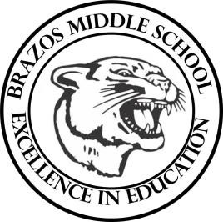

Teacher_Chris Stanley 6th Grade Social Studies 2023
Week 6- 1st- 6 weeks | September 18th – 22nd

Monday |  | Thursday
TEKS: 15A, 15B, 17A, 17B, 4B, 16A, 16B, 16C  TLW:  1. Culture is the set of beliefs, goals, and practices that a group of people share.  2. The world includes many different culture groups  3. The study of population patterns helps geographers  learn about the world.  4. Population statistics and trends are important  measures of population change  5. Features common to all cultures are call cultural  universals. SWL all societies have social intuitions |  | TEKS: 3C 8A 8B 9A 9B  1.Students will learn about the World’s Economy and how the United States benefits from the free enterprise system.
Tuesday |  | Friday
TEKS: 5A, 17A, 15A, 15B, 17C  Section 2 Quiz  1. Globalization links the world’s countries together  through culture and trade.  2. The world community works together to solve global conflicts and crises.  Students will recall information over  chapter 4 and complete Chapter review.  Start Chapter 5 over Governments and  Economic systems. Chapter review |  | TEKS: 1A 2B 4C 15D 18D 4B 5A 6B 7B 21C  TLW:  1.The United States is the world’s first modern democracy.  2. The people and culture of the United States are very  diverse.  3. Canada has a democratic government with a prime minister and a parliament.  4. Canada has four distinct geographic and cultural  regions.  5. Canada’s economy is largely based on trade with the United States.
Wednesday
TEKS: 11A, 11B, 13A, 13B
Students will learn that limited governments
of the world include democracies, and Unlimited
governments of the world include Totalitarian
governments.
Students will learn what the duties and roles of citizenship help make representative governments work.

