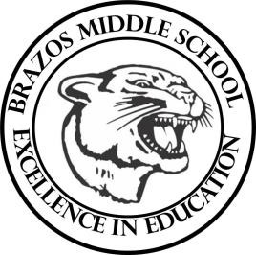

Teacher_Chris Stanley 7th Grade TX History 2023
Week 4- 1st- 6 weeks | September 4th – 8th

Monday |  | Thursday
OFF |  | TEKS: 7.1A, 7.2B  Objective: Students will continue to work  on their collage project over the  different Indian Cultures.  Vocabulary Quiz over regions and Indian cultures
Tuesday |  | Friday
TEKS: 7.1A, 7.2A  TLW: Students will identify and explore the  Plains culture. Students will identify  the region the Indians lived and  characteristics of their culture.  Students will review the Pueblo  Culture ( tribes, location in Texas, diet,  shelter, and information about their  culture.)  Students will be given the material  over the Plains Indians and we will  identify characteristics together  reading through the summary from the  textbook. Students will then read their  specific Indians groups information and  then chart information in the graphic organizer. |  | TEKS: 7.1A, 7.1B  Objective: Students will complete questions over the Indian Cultures using their collage projects. They will also complete a graphic organizer choosing 2 indian cultures and comparing their differences and similarities.
Wednesday
TEKS: 7.1A, 7.2A
Students will create a collage
project for each culture of Indians
focusing on lifestyle, homes, culture,
beliefs and customs as well as the
area of Texas they are located.
Students will review the Plains culture
and go over notes on the graphic
organizer.

