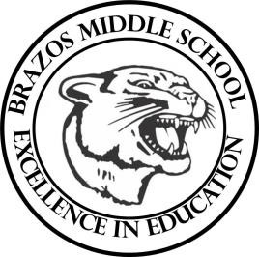

Teacher_Chris Stanley 7th Grade TX History 2023
Week 3- 1st- 6 weeks | August 28 – September 01

Monday |  | Thursday
Teks: 7.8A, 7.8B, 7.9A  Objective: Students will continue their study on regions. They will work on identifying main characteristics of the region sub regions. Warm- up Questions over regions  Introduce new vocabulary quiz Thursday September 7th  Quiz over regions of Texas on Wednesday. |  | TEKS: 7.1A, 7.1B  Objective: Students will identify and explore the Southeastern culture. Students will identify the region the Indians lived and characteristics of their culture. Students are creating a graphic organizer
Tuesday |  | Friday
TEKS: 7.8A, 7.8B, 7.9A  TLW: students will complete an information sort about the region.  Warm-up finish questions over regions  Start region post card activity Due Friday, September 1st  Students will complete any missing daily work activities. |  | TEKS: 7.1A, 7.1B  Objective: Students will identify and explore the Pueblo culture. Students will identify the region the Indians lived and characteristics of their culture. Students are creating a graphic organizer.
Wednesday
TEKS: 7.1A, 7.1B
Objective: Students will identify and explore the Western Gulf culture. Students will identify the region the Indians lived and characteristics of their culture. Students are creating a graphic organizer

Texans Indians Vocab

Quiz over Regions

