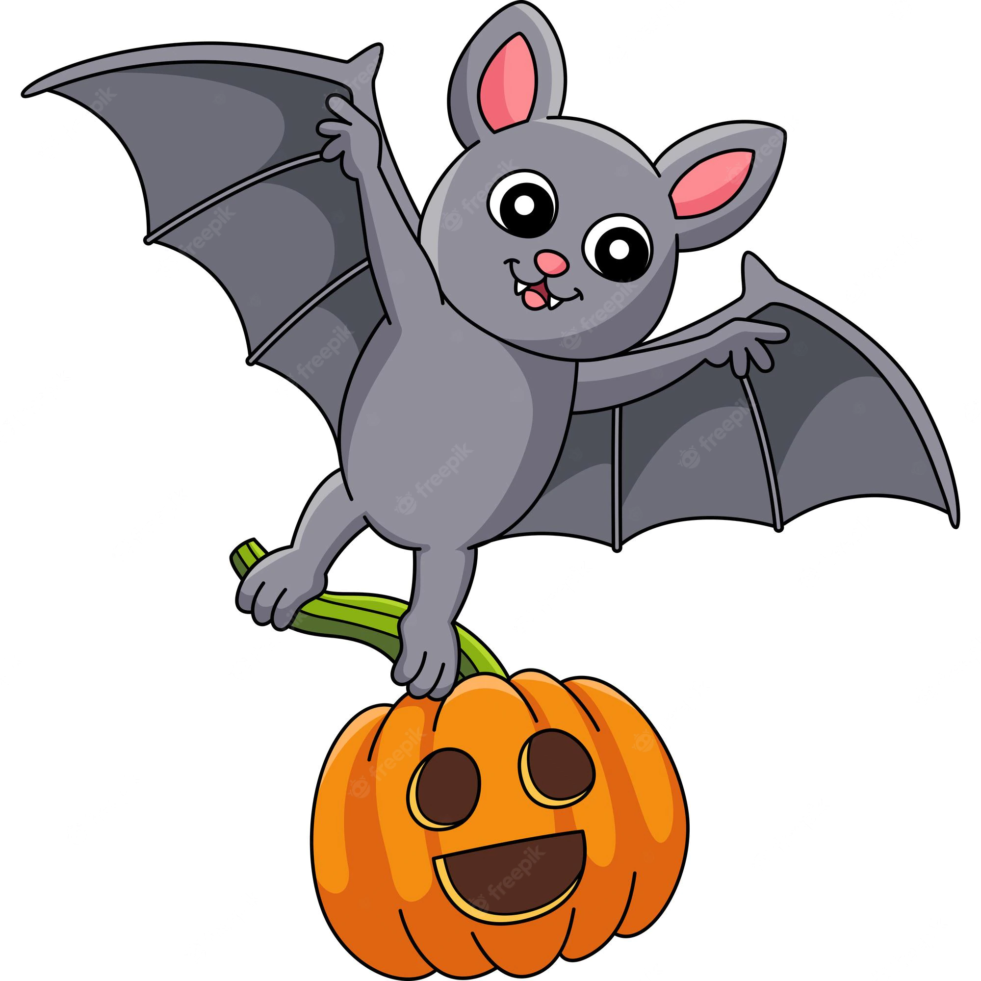
1st Grade
Peek of the Week
October 13 - 17, 2025

Spelling Words | nest pet slash jet shop taps shin just cloth kept be this
Sight Words | at be or have from
this
bath
splish
pal
brush
log
wish
she
plush
that
lash
has

Practice Reading These Words

At school, we are learning…
~ Reading: Fables
~ Writing: Letter Formation/Handwriting; Interrogative
sentences
~ Phonics/Spelling: review short vowel, th, sh
~ Math: Subtraction
~ Science: Changes from Heat; Weather
~ Social Studies: Patriotism
Dates to Remember:

October 18 - PTE Harvest Festival

October 28 - 1st Grade Parent Lunch Day

Homework
~ READ!!

~ Practice sight words & spelling words

~ Practice Page on back of the Peek of the Week

Skills Practice Homework Page
Please complete throughout the week & return on Friday!
Name one thing firefighters wear or use. Draw a picture. | What number is this?  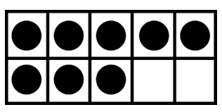
Write 3 words with the short “u” sound.  ______________  _____________ | Draw the dot pattern for 3.
Circle the words.  b cab y e  j o hot s t  Mom I h it q  put v is | Write an addition & subtraction number sentence for this picture.  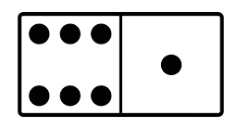  ______ + _______ = ______  ______ - _______ = ______
Finish the sentence.  Apples are  ______________. | What part of our body do we use to hear with? Draw it below.

