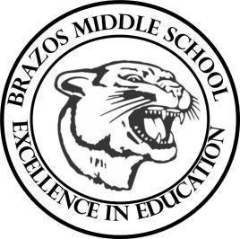

Teacher____Mrs. Wilcox ____6th Grade Reading_____

| Week 5 | Date: September 8-12 |
| --- | --- |

| Monday |  | Thursday |
| --- | --- | --- |
| TEKS# 6.5B, 6.5F, 6.5G, 6.5H, 6.6D, 6.8A  Objective:  Warm Up: The learner will complete a STAAR Practice Reading Passage.  TLW…take a quiz over academic Vocabulary Set #2 DG  TLW…begin Book Study #1; The Lion, The Witch, and The Wardrobe (vocabulary review) |  | TEKS# 6.5B, 6.5F, 6.5G, 6.5H, 6.6D, 6.8A  Objective: BOOK STUDY  Warm Up: The learner will complete a STAAR Practice Reading Passage.  TLW…Read The Lion, The Witch, and The Wardrobe  Chapter 3 and complete classroom discussions/activity. |
|  |  | |
| Tuesday |  | Friday |
| TEKS# 6.5B, 6.5F, 6.5G, 6.5H, 6.6D, 6.8A  Objective: BOOK STUDY  Warm Up: The learner will complete a STAAR Practice Reading Passage.  TLW…Read The Lion, The Witch, and The Wardrobe  Chapter 1 and complete classroom discussions/activity. | TEKS# 6.5B, 6.5F, 6.5G, 6.5H, 6.6D, 6.8A  Objective: BOOK STUDY  Warm Up: The learner will complete a STAAR Practice Reading Passage.  TLW…Read The Lion, The Witch, and The Wardrobe  Chapter 4.  TLW…take a quiz over Chapters 1-4 DG |
|  |  | |
| Wednesday |  |  |
| TEKS# 6.5B, 6.5F, 6.5G, 6.5H, 6.6D, 6.8A  Objective: BOOK STUDY  Warm Up: The learner will complete a STAAR Practice Reading Passage.  TLW…Read The Lion, The Witch, and The Wardrobe  Chapter 2 and complete classroom discussions/activity. |  |  |