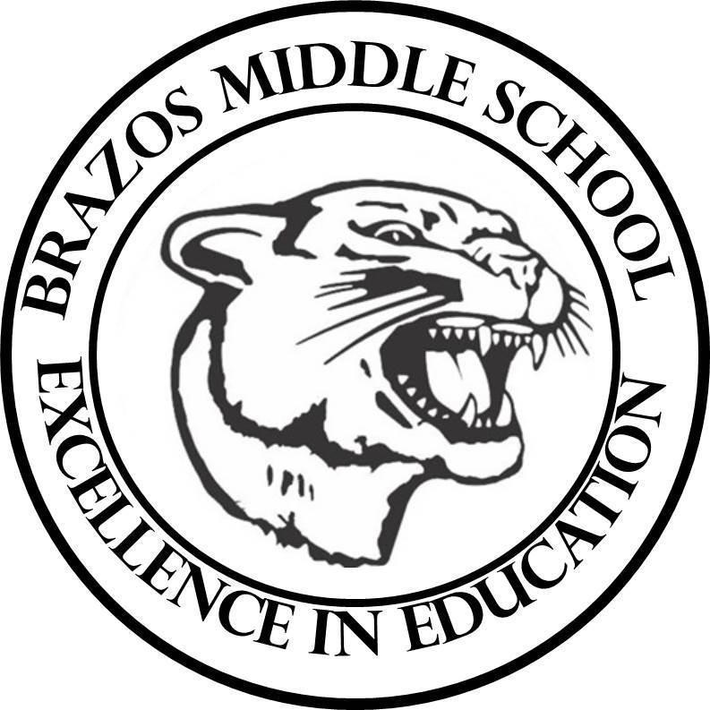

Teacher: Dawn Prihoda

| Week 2 Se | September 30 - October 4, 2024 | | 6th Science | |
| --- | --- | --- | --- | --- |
| Monday 9/30/24 | |  | | Tuesday 10/1/24 |
| TEK: 6.6D “Relative Density”  Objective:   * I can compare the density of different substances and fluids.   TLW:   * Warm Up: Day 1   “Relative Density” - 2nd Week Covering  - Grade Friday   * Vocabulary Quiz from last week is moved to Wednesday (No new vocabulary words for this week) * Student Notebook Pg. 63   Engage - Scope Phenomenon  “Layering Liquids”   * Elaborate - Content Connection Video and Questions * Student Notebook Pg. 65   Explore: “Hashtag”Rainbow in a Jar”   * Lab: “Rainbow in a Jar” Pg. 66-69 * Match Game Cards Activity | | TLW: 6.6D “Relative Density”  Objective:   * I can compare the density of different substances and fluids.   TLW:   * Warm Up - Day 2   “Relative Density”  - Grade Friday   * Vocabulary Quiz from last week is moved to Wednesday (No new vocabulary words for this week) * Review Unit Test “Relative Density” -   Grade x 2 (Test will be next week Thursday)   * Relative Density - Notes/Activity   and Sink or Float Practice   * Student Notebook: pg. 70   Claim-Evidence-Reasoning   * Student Notebook: Pgs. 72-76   Virtual Explore (use Chromebook) |
| Wednesday 10/2/24 | |  | | Thursday 10/3/24 |
| TLW: 6.6D “Relative Density”  Objective:   * I can compare the density of different substances and fluids.   TLW:   * Warm Up - Day 3   “Relative Density”  - Grade Friday   * Vocabulary Quiz from last week is moved to Wednesday (No new vocabulary words for this week) * Student Notebook Pg.77   Claim-Evidence-Reasoning   * Student Notebook Pg. 79   STEMscope - “Stop and Jot”  use STEMscopedia (Hardcover Book)   * Con’t Student Notebook Pg.72-76   Explore: STEMscope - Virtual Explore  (use chromebook) | | TLW: 6.6D “Relative Density”  Objective:   * I can compare the density of different substances and fluids.   TLW:   * Warm Up - Day 4   “Relative Density”  - Grade Friday   * (No new vocabulary words for this week) * Unit Test “Relative Density” -   Grade x 2 (Test will be next week Thursday) |
| Friday 10/4/24 | |  | |  |
| TLW: 6.6D “Relative Density”  Objective:   * I can compare the density of different substances and fluids.   TLW:   * Warm Up - Day 5   “Relative Density”  - Grade Friday   * (No new vocabulary words for this week) * Voc. Quiz From Wednesday and Unit Test from Thursday Corrections * Blooket Review: “Relative Density” | |  |