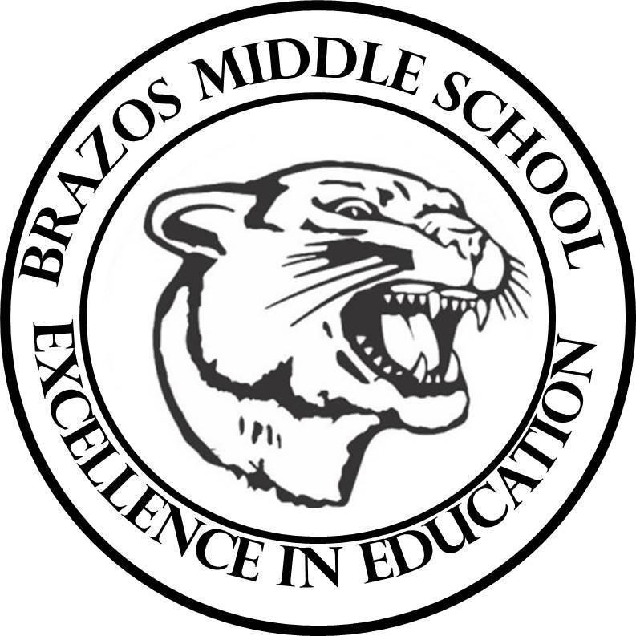

Teacher: Mrs. C

| 6TH Grade Science  4th 6 Weeks – Week 4  January 27 - January 31, 2025 | |
| --- | --- |
| Monday 1/27/25 | Tuesday 1/28/25 |
| AREA OF RECTANGLES AND PARALLELOGRAMS  GRADED | AREA OF TRIANGLES AND TRAPEZOIDS  GRADED |
| Wednesday 1/29/25  RECTANGLE/ parallelogram/ TRIANGLES/ TRAPEZOID AREA  GRADED | Thursday 1/30/25  QUICK CHECK- GEOMETRY  GRADED |
| Friday 1/31/25  MEASUREMENTS AND AREA |  |
|  |  |