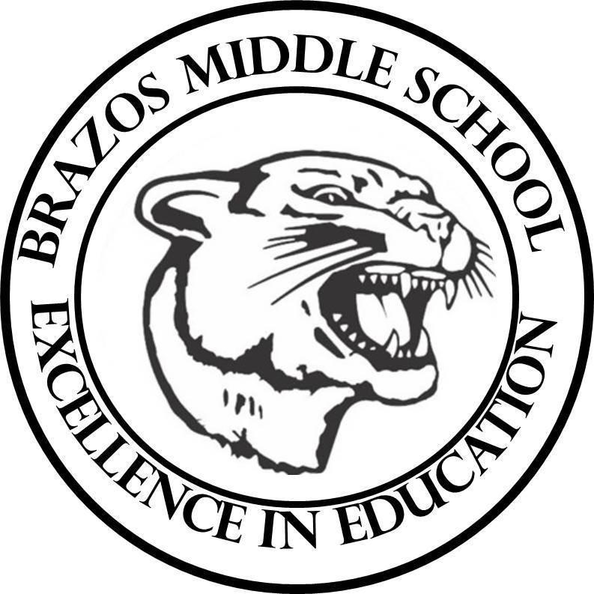

Teacher: Mrs. Prihoda

| 6TH Grade Science  3rd 6 Weeks – Week 4  December 2 - December 6, 2024 | |
| --- | --- |
| Monday 12/2/24 | Tuesday 12/3/24 |
| TEK: 6.7C “Newton’s Third Law”  Objective:  - I can identify simultaneous force pairs that are equal in magnitude and opposite in direction that result from the interactions between objects using Newton's Third Law of Motion  TLW:  Warm Up - Day 1 – Grade Friday  Corrections on Unit Test from Friday  -Pre Assessment: “Newton’s Third Law”  -Background Knowledge / Terms to Know Voc.  -Voc. Quiz: Friday - Grade (plus questions from pre-assessment)  -STEMscopedia (hardcover book) Read and  Complete Questions on paper copy. | TEK: 6.7C “Newton’s Third Law”  Objective:  - I can identify simultaneous force pairs that are equal in magnitude and opposite in direction that result from the interactions between objects using Newton's Third Law of Motion  TLW:  Warm Up - Day 2  -Con’t: STEMscopedia (hardcover book) Read and  Complete Questions on paper copy. |
| Wednesday 12/4/24 | Thursday 12/5/24 |
| TEK: 6.7C “Newton’s Third Law”  Objective:  - I can identify simultaneous force pairs that are equal in magnitude and opposite in direction that result from the interactions between objects using Newton's Third Law of Motion  TLW:  Warm Up - Day 3  -Explain: Content Connection  -Reading Science  -Virtual Explore  -Virtual Experience | TEK: 6.7C “Newton’s Third Law”  Objective:  - I can identify simultaneous force pairs that are equal in magnitude and opposite in direction that result from the interactions between objects using Newton's Third Law of Motion  TLW:  Warm Up - Day 4  --YouTube Kids: Video  -“Newton’s Third Law” -: Practice |
| Friday 12/6/24 |  |
| TEK: 6.7C “Newton’s Third Law”  Objective:  - I can identify simultaneous force pairs that are equal in magnitude and opposite in direction that result from the interactions between objects using Newton's Third Law of Motion  TLW:  Warm Up - Day 5  -Voc. Quiz: Friday - Grade  -Blooket Review |  |