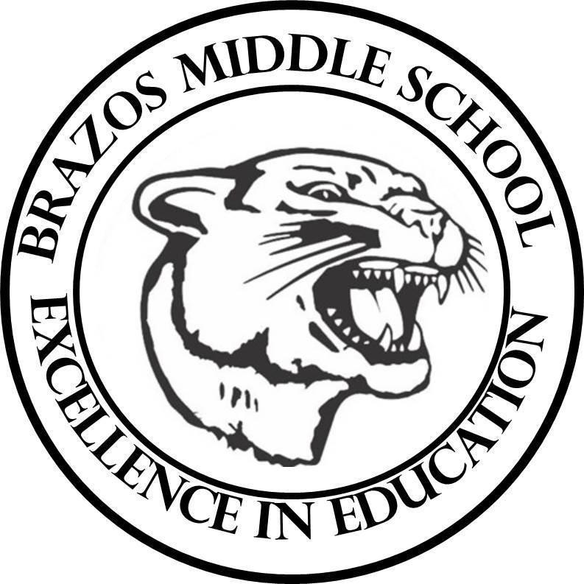

Teacher: Mrs. Prihoda

| 6TH Grade Science  2nd 6 Weeks – Week 6  October 28 – November 1, 2024 | |
| --- | --- |
| Monday 10/28/24 | Tuesday 10/29/24 |
| TEK: 6.7A “Forces on Objects”  Objective:  I can identify and explain how forces act on objects, including gravity, friction, magnetism, applied forces, and normal forces, using real-world applications  TLW:  -CBA #2: Corrections  -Warm Up - Day 1 “Chemical and Chemical Changes” – Grade Friday  -Voc. Quiz: Grade Friday  -Pre Assessment: “Forces on Objects”  -Background Knowledge / Terms to Know Voc.  -Student Notebook: “The Force of Attraction”  -STEMscopedia (hardcover book)  Read “Forces on Objects”  Complete Questions on paper copy from hard cover book  Complete Questions from student notebook -Both sets of Questions are a combined - Grade | TEK: 6.7A “Forces on Objects”  Objective:  I can identify and explain how forces act on objects, including gravity, friction, magnetism, applied forces, and normal forces, using real-world applications  TLW:  -Warm Up - Day 2 “Chemical and Chemical Changes” – Grade Friday  -Voc. Quiz: Grade Friday  -Con’t: -Student Notebook: “The Force of Attraction”  -STEMscopedia (hardcover book)  Read “Forces on Objects”  Complete Questions on paper copy from hard cover book  Complete Questions from student notebook -Both sets of Questions are a combined - Grade |
| Wednesday 10/30/24 | Thursday 10/31/24 |
| TEK: 6.7A “Forces on Objects”  Objective:  I can identify and explain how forces act on objects, including gravity, friction, magnetism, applied forces, and normal forces, using real-world applications  TLW:  -Warm Up - Day 3 “Chemical and Chemical Changes” – Grade Friday  -Voc. Quiz: Grade Friday  - Doodle Notes: Identifying Types of Forces Acting on an Object  -Explain: Content Connection  -Gimkit Review: Forces on Objects | TEK: 6.7A “Forces on Objects”  Objective:  I can identify and explain how forces act on objects, including gravity, friction, magnetism, applied forces, and normal forces, using real-world applications  TLW:  -Warm Up - Day 4 “Chemical and Chemical Changes” – Grade Friday  -Voc. Quiz: Grade Friday  -Reading Science: “Formula One Braking Systems”  -Virtual Explore: “The Evidence is Clear” |
| Friday 11/1/24 |  |
| TEK: 6.7A “Forces on Objects”  Objective:  I can identify and explain how forces act on objects, including gravity, friction, magnetism, applied forces, and normal forces, using real-world applications  TLW:  -Warm Up - Day 5 “Chemical and Chemical Changes” – Grade Friday  -Voc. Quiz: Grade Friday  -Student Notebook: “Forces on Objects |  |