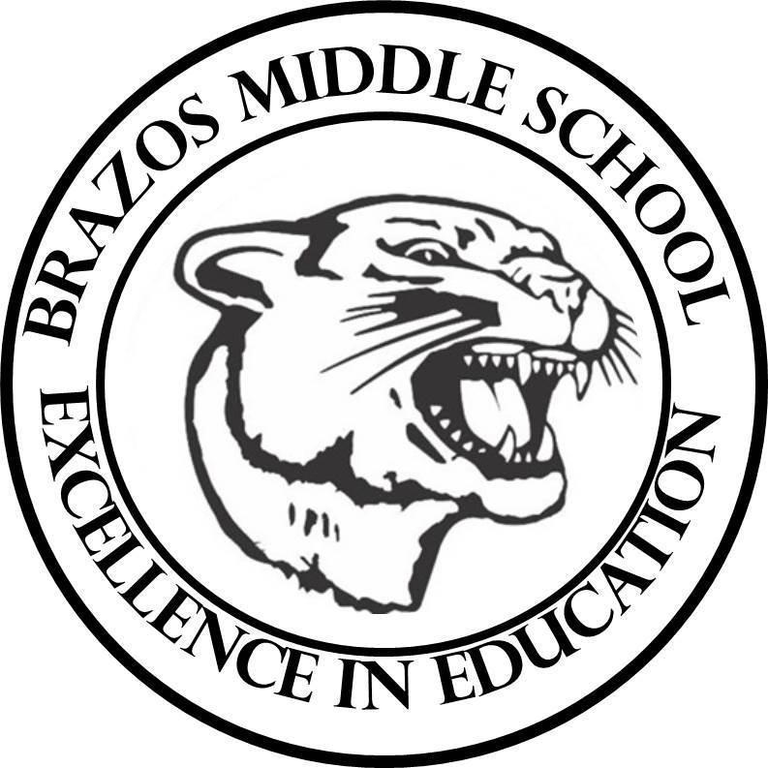

Teacher: Dawn Prihoda

| Week 3 | October 7 - 11, 2024 | | 6th Science | |
| --- | --- | --- | --- | --- |
| Monday 10/7/24 | |  | | Tuesday 10/8/24 |
| TEK: 6.6D “Relative Density”  Objective:   * I can compare the density of different substances and fluids.   TLW:   * No Warm Up * No Vocabulary * Work on Corrections * Blooket Review | | TLW: 6.6D “Relative Density”  Objective:   * I can compare the density of different substances and fluids.   TLW:   * No Warm Up * No Vocabulary * Work on Corrections * Blooket Review |
| Wednesday 10/9/24 | |  | | Thursday 10/10/24 |
| Student Fair Holiday  Teacher Work Day | | Fair Holiday |
| Friday 10/11/24 | |  | |  |
| Fair Holiday | |  |