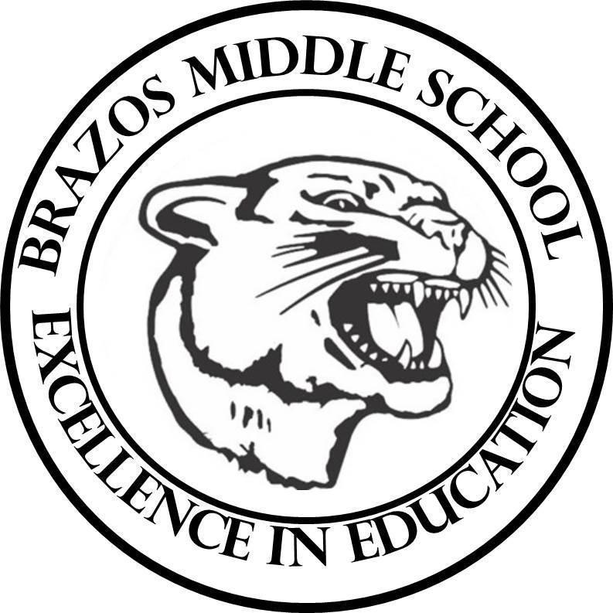

Teacher: Dawn Prihoda

| 2nd 6 Weeks - Week 1 | September 23-27, 2025 | | 6th Science | |
| --- | --- | --- | --- | --- |
| Monday 9/23/24 | |  | | Tuesday 9/24/24 |
| TEK: 6.6C “Metals, Nonmetals, and Metalloids”   * Review for Unit Test   Test will be on Wednesday (Grade X 2)  TEK: 6.6D “Relative Density”  Objective:   * I can compare the density of different substances and fluids.   TLW:   * Warm Up - Day 1   “Metals, Nonmetals, and Metalloids” (2)  - Grade Friday   * Pre Assessment * Background - Relative Density/   Study “Terms to Know” Voc. Quiz Friday - Grade   * STEMscopedia (Hard Cover) Pgs. 47-59 | | TEK: 6.6D “Relative Density”  Objective:   * I can compare the density of different substances and fluids.   TLW:   * Warm Up - Day 2   “Metals, Nonmetals, and Metalloids” (2) - Grade Friday   * Student Notebook Pg. 63   Engage - Scope Phenomenon  “Layering Liquids”   * Elaborate - Content Connection Video and Questions * Student Notebook Pg. 65   Explore: “Hashtag”Rainbow in a Jar”   * Lab: “Rainbow in a Jar” Pg. 66-69 |
| Wednesday 9/25/24 | |  | | Thursday 9/26/24 |
| TEK: 6.6D “Relative Density”  Objective:   * I can compare the density of different substances and fluids.   TLW:   * Warm Up - Day 3   “Metals, Nonmetals, and Metalloids” (2)  - Grade Friday  TEK: 6.6C Unit Test: “Metals, Nonmetals, and Metalloids” Grade   * Student Notebook Pg.70   Claim-Evidence-Reasoning | | TEK: 6.6D “Relative Density”  Objective:   * I can compare the density of different substances and fluids.   TLW:   * Warm Up - Day 4   “Metals, Nonmetals, and Metalloids” (2)  - Grade Friday   * Student Notebook Pg.72-76   Explore: STEMscope - Virtual Explore  (use chromebook) |
| Friday 9/27/24 | |  | |  |
| Fair Holiday for Students  Teacher Work day | |  |