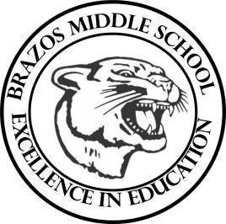

Teacher____Mrs. Wilcox ____6th Grade Reading_____
Week 7 | Date: October 6-10

Monday |  | Thursday
TEKS# 6.5B, 6.5F, 6.5G, 6.5H, 6.6D, 6.8A  Objective: BOOK STUDY  Warm Up: The learner will complete a STAAR Practice Reading Passage.  TLW…Read The Lion, The Witch, and The Wardrobe  Chapter 16 & 17 and complete classroom discussions/activity. |  | FAIR DAY  NO SCHOOL
Tuesday |  | Friday
TEKS# 6.5B, 6.5F, 6.5G, 6.5H, 6.6D, 6.8A  Objective: BOOK STUDY  Warm Up: The learner will complete a STAAR Practice Reading Passage.  TLW…Take a comprehensive Exam over the LWW MG |  | FAIR DAY  NO SCHOOL
Wednesday
FAIR DAY
NO SCHOOL

