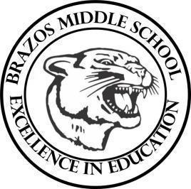

Teacher____Mrs. Wilcox ____6th Grade Reading_____
Week 5 | Date: September 8-12

Monday |  | Thursday
TEKS# 6.5B, 6.5F, 6.5G, 6.5H, 6.6D, 6.8A  Objective:  Warm Up: The learner will complete a STAAR Practice Reading Passage.  TLW…take a quiz over academic Vocabulary Set #2 DG  TLW…begin Book Study #1; The Lion, The Witch, and The Wardrobe (vocabulary review) |  | TEKS# 6.5B, 6.5F, 6.5G, 6.5H, 6.6D, 6.8A  Objective: BOOK STUDY  Warm Up: The learner will complete a STAAR Practice Reading Passage.  TLW…Read The Lion, The Witch, and The Wardrobe  Chapter 3 and complete classroom discussions/activity.
Tuesday |  | Friday
TEKS# 6.5B, 6.5F, 6.5G, 6.5H, 6.6D, 6.8A  Objective: BOOK STUDY  Warm Up: The learner will complete a STAAR Practice Reading Passage.  TLW…Read The Lion, The Witch, and The Wardrobe  Chapter 1 and complete classroom discussions/activity. |  | TEKS# 6.5B, 6.5F, 6.5G, 6.5H, 6.6D, 6.8A  Objective: BOOK STUDY  Warm Up: The learner will complete a STAAR Practice Reading Passage.  TLW…Read The Lion, The Witch, and The Wardrobe  Chapter 4.  TLW…take a quiz over Chapters 1-4 DG
Wednesday
TEKS# 6.5B, 6.5F, 6.5G, 6.5H, 6.6D, 6.8A
Objective: BOOK STUDY
Warm Up: The learner will complete a STAAR Practice Reading Passage.

TLW…Read The Lion, The Witch, and The Wardrobe
Chapter 2 and complete classroom discussions/activity.

