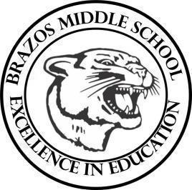

Teacher____Mrs. Wilcox ____6th Grade Reading_____
Week 12 | Date: October 27-31

Monday |  | Thursday
TEKS# 6.5F, 6.5E, 6.5 G, 6.5F, 6.5H, 6.6B, 6.6C, 6.6D, 6.7B, 6.7C, 6.9A, 6.10B, 6.10C, 6.10D, 6.11B  Objective: Short Constructed Responses  Warm Up: The learner will complete a STAAR Practice Reading Passage.  TLW…receive and review academic vocabulary set 3.  TLW…participate in a whole group instruction while taking notes over short constructed responses. |  | TEKS# 6.5F, 6.5E, 6.5 G, 6.5F, 6.5H, 6.6B, 6.6C, 6.6D, 6.7B, 6.7C, 6.9A, 6.10B, 6.10C, 6.10D, 6.11B  Complete CBA- Major Grade  TLW… complete a vocabulary set 3 practice page for a daily grade.
Tuesday |  | Friday
TEKS# 6.5F, 6.5E, 6.5 G, 6.5F, 6.5H, 6.6B, 6.6C, 6.6D, 6.7B, 6.7C, 6.9A, 6.10B, 6.10C, 6.10D, 6.11B  Objective: Short Constructed Responses  Warm Up: The learner will complete a STAAR Practice Reading Passage.  TLW…review their notes over short constructed responses and complete a practice response. |  | STUDENT HOLIDAY
Wednesday
TEKS# 6.5F, 6.5E, 6.5 G, 6.5F, 6.5H, 6.6B, 6.6C, 6.6D, 6.7B, 6.7C, 6.9A, 6.10B, 6.10C, 6.10D, 6.11B

CBA- Major Grade

