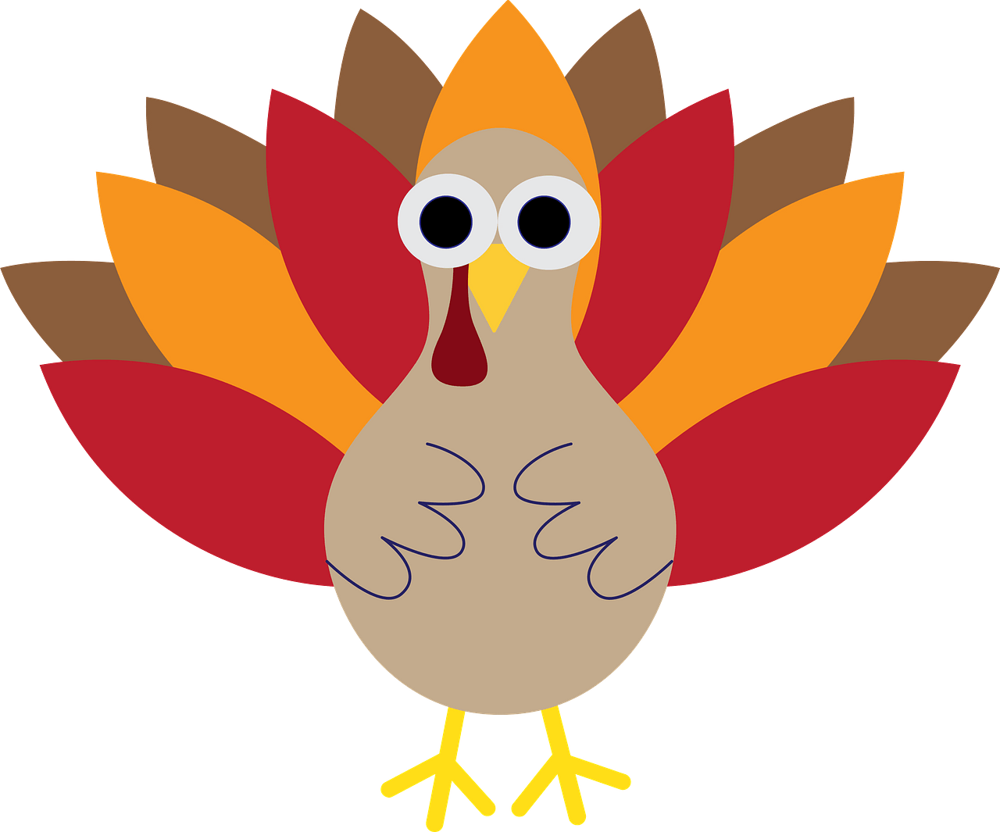
1st Grade
Peek of the Week
November 3 - 7, 2025

Spelling Words | chick neck sock shack catch edge judge itch fetch dodge we all
Sight Words | your can said there down

latch
edge
witch
hutch
stitch
hedge
itch
chill
stick
branch
lunch
champ
luck

Practice Reading These Words

At school, we are learning…
~ Reading: Folktales
~ Writing: Letter Formation; Singular & Plural Nouns
~ Phonics/Spelling: review short vowel, dge, tch
~ Math: Making 10 when an addend is 8
~ Science: Seasons
~ Social Studies: Important Citizens in Texas History
Dates to Remember:

November 5 - 1st Grade Parent Lunch Day

November 7 - Fundraiser Delivered

November 14 -

November 21 - Early Release

Skills Practice Homework Page
Please complete throughout the week & return on Friday!

Circle the pictures that rhyme.  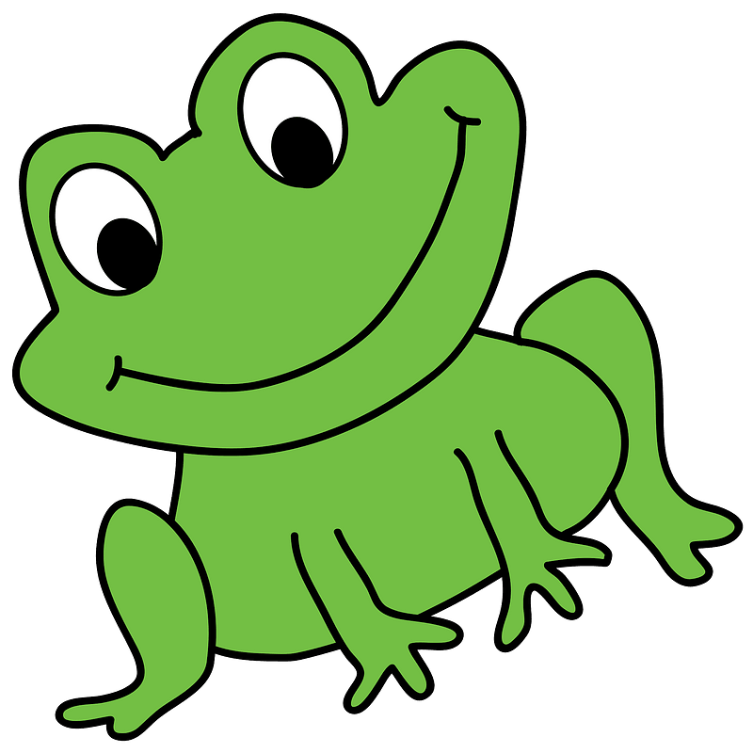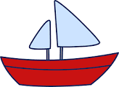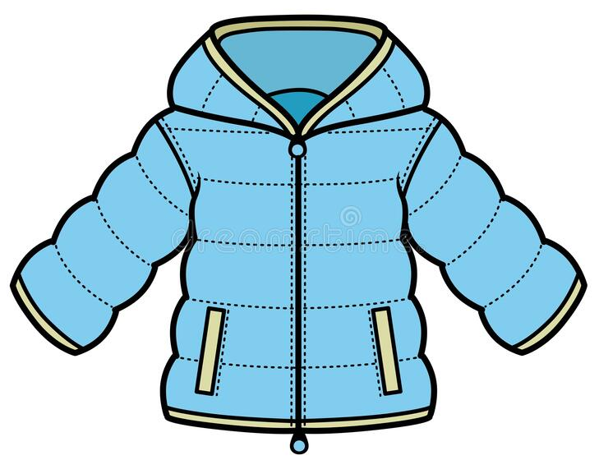 | Fill in the missing numbers.  ____ 16 ____ 18
Circle the verb in the sentence.  Bob runs to the school. | What country do we live in?
Circle the nouns.  the cat will  hug lip clap frog  pig run ship | Write 2 subtraction sentences (aka math problem) for this picture.  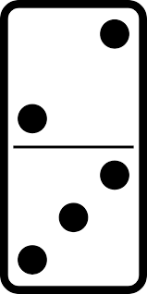  ______ - _______ = ______  ______ - _______ = ______
Finish the sentence.  I can ________ in my bed. | Draw a picture of something that gives us light.

