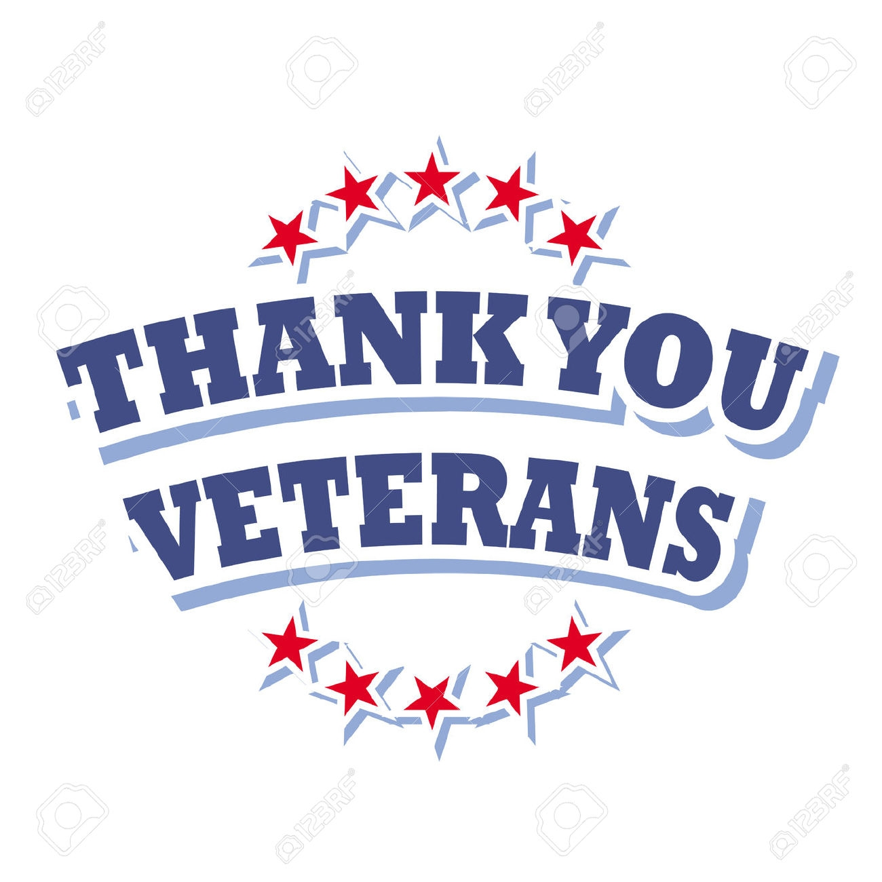
1st Grade
Peek of the Week
November 10 - 14, 2025

Spelling Words | mess kiss toss boss less bill pill huff cuff class  she an
Sight Words | an come which she do

glass
flock
thrill
hitch
ball
miss
bridge
Floss
fall
dodge
will
ledge
chill
Batch
mall
puff

Practice Reading These Words

At school, we are learning…
~ Reading: Folktales
~ Writing: Letter Formation/Handwriting; Proper Nouns
~ Phonics/Spelling: review short vowel, double
consonant ending, -all words
~ Math: Subtraction Word Problems
~ Science: Soil
~ Social Studies: Veteran’s Day & Founders
Dates to Remember:

November 11 - Picture Retake Day

November 21 - Early Release @ 12:15

November 24 - 28 - Thanksgiving Holidays ~ No School

Skills Practice Homework Page
Please complete throughout the week & return on Friday!
Rainbow write your spelling words.  - ________________________  - ________________________  - ________________________  - ________________________  - ________________________  - ________________________  - ________________________  - ________________________  - ________________________  - _______________________  - _______________________  - _______________________ | Solve  3 + ____ = 7
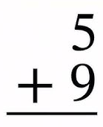
Use the ten frames to solve.
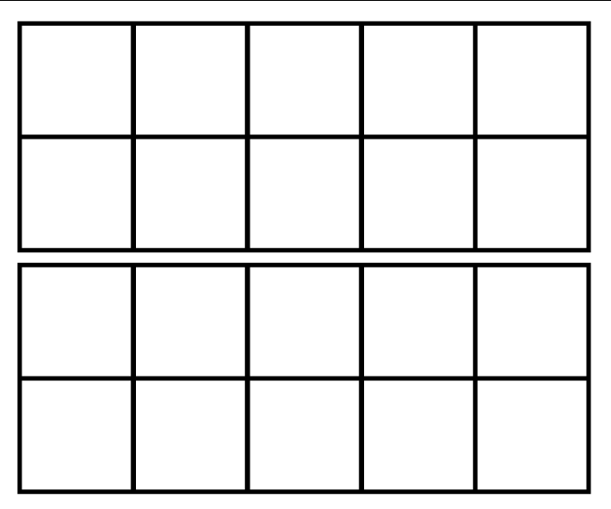
Circle the verbs.

run when play

pal sing can

clap hot shop

 | What are you thankful for?

