Ag Mechanics/Power Fab
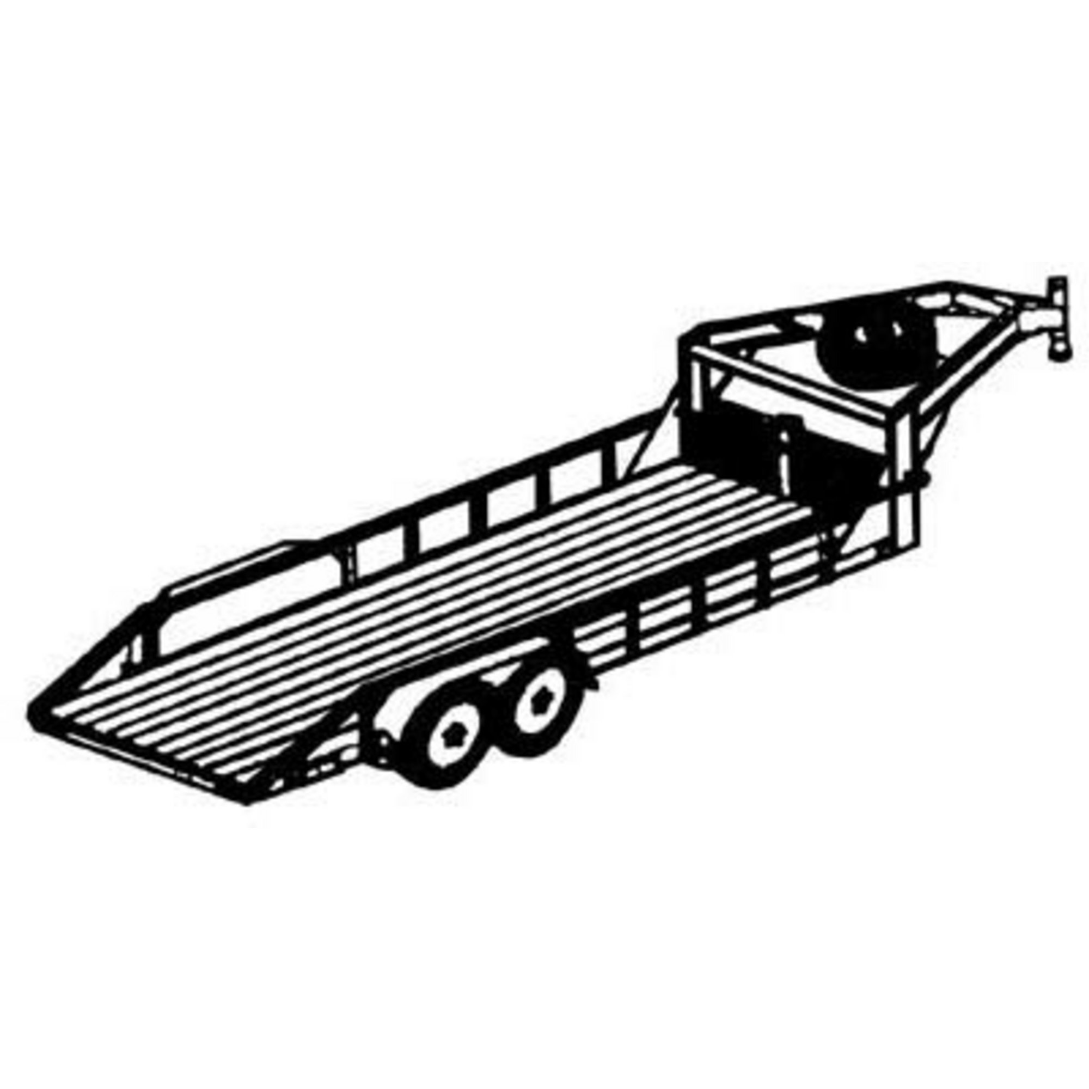
Course designed to introduce basic theory and specialized skills in agricultural mechanics. Skills to be developed include tool identification and safe use, carpentry, electricity, painting, metal working, welding and other skills.

FFA: All Agri-Science courses at Brazos High School provide students with, opportunities for participation in the FFA. FFA activities are optional , but impact learning in a major way.

FFA Membership dues $ 25.00

Contact: Mr. Graham Borden
gborden@brazosisd.net
979-478-6832 Main office

Conference: 5th period ( 11:20- 12:05 )

Grading:

Your final grade will be based on your progress throughout the semester in the areas of applied skills, test, and daily work. The test grades come from satisfactorily completing applied skill projects and test. You will earn a minimum 6 daily grades and 2 major grades per grading period. The daily work portion of your final grade includes homework, notebook, record book, and daily participation. They will be weighted as follows:

Tests and Projects 40%
Daily Work 60%

Class participation grades will be based on the following scale.
Student exhibits on-task behavior and attitude the entirety of the class period-90-100
Student exhibits on-task behavior and attitude more than half of the class period-80-89
Student occasionally exhibits off-task behaviors and attitudes-70-79
Student regularly exhibits off-task behaviors and attitudes-60-69
Student does not participate-less than 59.

Late Work Policy: 1 day late-20 pts
2 days late-30 pts
3 days late- 0
*Students that receive a zero will be assigned to Champion Drive to complete the assignment. The highest grade that can be earned on world that is more than 3 days late is a 50.
Tutorials - upon request before and after school.

Materials: Pen, Paper, & 2 pocket folder or binder

Personal Protective Equipment.
-safety glasses, face shields, gloves, welding helmets, will all be provided however students are welcome to bring their own equipment.
-students WILL be responsible for bringing and wearing jeans, closed toe shoes and a long sleeve work shirt while working in the shop. Shirt must be made out of cotton, or some type of Fire Resistant material. THIS IS MANDATORY!!

Safety :
Students must master concepts in classroom before working in shop and / or lab. Students must work & work safely to retain shop privileges .

Student Expectations:
- Be on time to class with all materials.
- Make a habit of reading the board as you enter the class for the warm-ups and daily assignments.
- Display respect at all times to everyone in the classroom.
- No food and drinks in the classrooms. WATER ONLY!!!!!!!!!
- Stay in your seat. When you are finished with your assignment you may work on something else quietly. Please do not disrupt others.
- Clean up after yourself
- Follow Brazos Acceptable Use Policies regarding technology.
- BYOD with permission
- Follow all Brazos ISD rules.
- Follow all shop rules
- Follow all other Brazos HS expectations.

Consequences:
Step 1-warning
Step 2-teacher/student discussion after class—loss of classroom- SHOP privileges
Step 3-call home
Step 4-visit to the principal

